Clarifying Consciousness

Inter-Religious Inquiry, Meditation, Prayer, Satsang, Talk Story

Every Monday in July
7AM to 9AM

Kukui Room
Princeville of Hanalei Commuity Center
4334 Emmalani Drive

Princeville, HI 96722

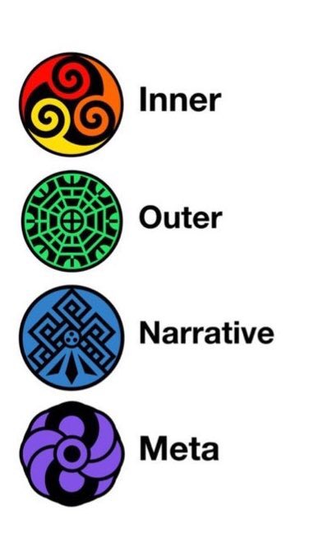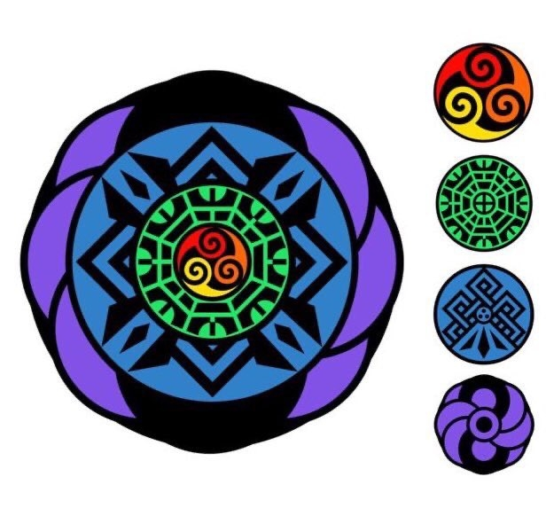
Artwork: Jamie Combs

COST: Kaʻana. Take what you need. Give what you can.
All welcomed. He mai nā kānaka āpau.

